Section 01

1.1 Problem Description and Relevance
In the rapidly evolving technological landscape, employee attrition—commonly referred to as "Flight Risk" remains a critical challenge for organizations. For this assignment, the focus is on Predicting Tech Talent Attrition in a Shifting AI Landscape.
Traditional attrition models often focus on salary and tenure, but they fail to capture modern stressors such as "AI Anxiety" (the fear of role automation) and organizational instability (layoff rates). This problem is highly relevant to the local tech industry because:
- Cost of Replacement: Losing skilled talent results in high recruitment and training costs.
- Knowledge Loss: Attrition leads to a drain of institutional knowledge, affecting project continuity.
- Proactive Retention: A predictive model allows HR to intervene with reskilling or support before an employee resigns.

1.2 Data Source and Collection Methodology
The dataset for this study was locally compiled through a primary survey using Microsoft Forms.
- Method: The survey was distributed to a diverse group of local professionals to capture current market sentiment regarding workplace dynamics and AI impact.
- Size: The dataset consists of 173 unique entries.
- Target Variable: The target variable is Attrition_Intent, a binary classification where 1 indicates a plan to leave within 6 months and 0 indicates a plan to stay.

1.3 Features and Target Variable
The dataset consists of various predictors that capture professional, environmental, and technological sentiments.

Feature Name | Description | Data Type
Department | The functional area where the employee works. | Categorical
Monthly_Overtime | Average hours worked beyond standard contract. | Numerical
Years_Since_Promotion | Time elapsed since the last official role change. | Numerical
Job_Satisfaction | Employee’s self-reported happiness (Scale 1-5). | Numerical
AI_Automation_Risk | Perception of role automation by AI (Scale 1-5). | Numerical
Recent_Layoffs | Whether the department saw firing/layoffs in 12 months. | Binary (0/1)
Market_Demand | Ease of finding a similar role externally. | Categorical
Attrition (Target) | Intent to leave the company within 6 months. | Binary (0/1)

1.4 Dataset Size and Preprocessing
- Dataset Size: The final dataset used for training consists of 173 unique responses.
- Cleaning: The data was audited for missing values and duplicates to ensure high data quality.
- Encoding: Categorical variables (such as 'Department' and 'Market_Demand') were prepared for the model. While the selected CatBoost algorithm handles categories natively, Boolean flags were converted to 0/1 for computational efficiency.
- Normalization: Numerical features like 'Monthly_Overtime' were reviewed to ensure the model correctly weights their influence relative to the 1-5 scales.

1.5 Ethical Data Use
Strict ethical standards were maintained during the collection process:
- Anonymity: No personal or sensitive data (e.g., names, emails, specific company names) was collected, ensuring zero risk of deanonymization.
- Informed Consent: Every respondent was informed that their data would be used for academic machine learning research, and participation was entirely voluntary.

Section 02

2.1 Algorithm: CatBoost
CatBoost is an open-source gradient boosting library that belongs to the family of boosted decision trees. It is particularly well known for its superior performance with categorical datasets.

Justification for Selection
- Native Handling of Categorical Data: Standard models like Logistic Regression or k-NN require manual "One-Hot Encoding" or "Label Encoding" to turn categories (e.g., Department names) into numbers. CatBoost handles these automatically using a process called Ordered Boosting, which prevents "data leakage" and leads to better accuracy.

- Reduced Overfitting: Unlike standard Decision Trees that can easily "memorize" a small dataset, CatBoost uses an Ordered Boosting approach that improves the model’s ability to generalize to new, unseen data.

- Robustness to Tuning: While standard algorithms like Support Vector Machines (SVM) require extensive hyperparameter tuning to work well, CatBoost often provides high performance even with default settings, making it efficient.

- Efficiency with Tabular Data: Research consistently shows that Gradient Boosting models outperform Deep Learning for tabular datasets.

2.2 How it differs from "Standard" Models
Feature | Decision Tree | Logistic Regression | k-Nearest Neighbors (k-NN) | CatBoost
Data Handling | Requires numerical encoding for categorical variables. | Strictly requires numerical input; sensitive to outliers and unscaled data. | Strictly requires numerical input; highly sensitive to unscaled data | Native support for categorical features (no manual encoding needed); handles missing values automatically.
Learning Method | Greedy Splitting: Builds a single tree by recursively splitting data to maximize purity. Independent learning. | Linear Optimization: Fits a linear equation (weights + bias) to separate classes using a fixed boundary. | Lazy Learning: Does not "learn" a model; stores data and classifies based on distance to nearest neighbors. | Gradient Boosting: Builds an ensemble of trees sequentially, where each new tree corrects the errors of the previous ones.
Model Structure / Symmetry | Asymmetric Trees: Trees grow deep and irregular based on the best split at each node, often leading to overfitting. | Linear Structure: Flat equation. No tree structure or depth. | No Structure: Instance based, defined entirely by the density of local data points. | Symmetric Trees: Uses the same split criterion across an entire level of the tree. This regularization prevents overfitting and speeds up prediction.
Performance on Small Data | High Variance: Slight changes in data can create a totally different tree. Prone to overfitting. | High Bias: Likely to underfit if the relationship between features (e.g., Satisfaction vs. Attrition) is non-linear. | Noisy: Performance degrades rapidly with noisy data or irrelevant features (common in surveys). | Robust: Specifically designed to handle small datasets and reduce overfitting via "Ordered Boosting" and symmetric trees.

Section 03

3.1 Train / Validation / Test Split
- The Split: 80/20 split is used for the initial data. 80% of the data will be used for training, and 20% will be held back as a test set to evaluate final performance.
- Validation: Within the training phase, CatBoost internally uses a validation set (or cross-validation) to monitor performance and prevent "overfitting".
- Stratification: Because attrition is often imbalanced, stratified sampling is used. This ensures that both the training and testing sets have the same percentage of "Leavers" as the original dataset, preventing the model from becoming biased toward the majority class.

3.2 Hyperparameter Choices
- Iterations (n_estimators): Set to 1000. This is the maximum number of trees the model will build.
- Learning Rate (eta): Set to 0.03. A smaller learning rate makes the model learn more slowly but results in better accuracy by avoiding overshooting the optimal solution.
- Depth: Set to 6. This controls how complex each individual tree is.
- Early Stopping: Used early_stopping_rounds=50. If the model's performance on the validation set does not improve for 50 rounds, it stops training automatically to prevent it from "memorizing" the noise in the data.

3.3 Performance Metrics Used
For a classification task like predicting if someone leaves (1) or stays (0), accuracy alone is not enough.
- F1-Score: This is the most important metric for attrition. It balances Precision (how many predicted leavers actually left) and Recall (how many actual leavers the model caught).
- AUC-ROC: This measures the model’s ability to distinguish between "Leavers" and "Stayers" regardless of the threshold used.
- Accuracy: While useful, it can be misleading if 90% of people stay; a model could get 90% accuracy just by guessing "Stay" every time.

3.4 Results and Interpretation
The model was evaluated on a held out Test Set of 36 employees (20% of the total dataset). The evaluation focuses on the model's ability to correctly identify employees at risk of attrition while minimizing false alarms.

Key Metrics Summary

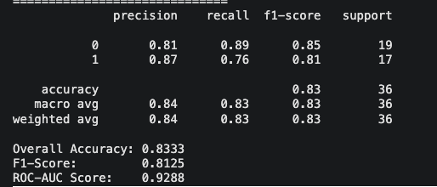
The model achieved high performance across all standard classification metrics, indicating strong predictive capability despite the small dataset size.
Metric | Value | Interpretation
Accuracy | 83.33% | The model correctly predicted the outcome (Stay vs. Leave) for 30 out of 36 employees.
F1-Score | 0.8125 | A strong balance between Precision and Recall, crucial here since the classes are slightly imbalanced.
ROC-AUC | 0.9288 | An AUC of 0.93 means the model has a 93% probability of distinguishing between a "Stayer" and a "Leaver" correctly.

B. Confusion Matrix Analysis

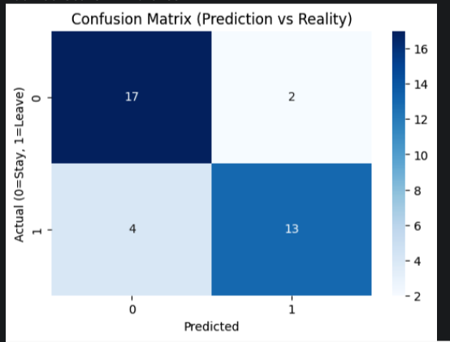
- True Positives (13 employees):
  - Result: The model correctly identified 13 employees who were actually leaving.
  - Precision (Class 1): 87% – When the model predicts someone will leave, it is correct 87% of the time.
- False Negatives (4 employees):
  - Result: The model predicted these 4 would Stay, but they actually Left.
- False Positives (2 employees):
  - Result: The model predicted they would Leave, but they actually Stayed.
- True Negatives (17 employees):
  - Result: The model correctly identified 17 loyal employees.

C. ROC Curve Analysis

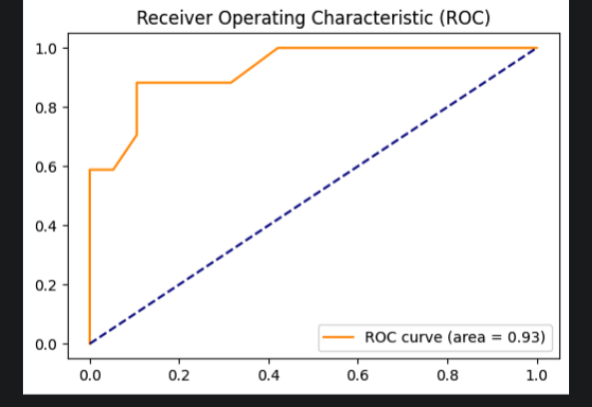

The ROC curve rises sharply toward the top-left corner, confirming that the model performs significantly better than random guessing.
- Area Under Curve (AUC) = 0.93: This high score suggests the model is very confident in its separation.
Section 04

To interpret the "black box" nature of the CatBoost model, I applied SHAP for global feature importance and LIME for local instance explanation. This analysis answers what the model has learned, which features drive decisions, and whether these findings align with real-world HR expectations.

A. Which features are most influential?
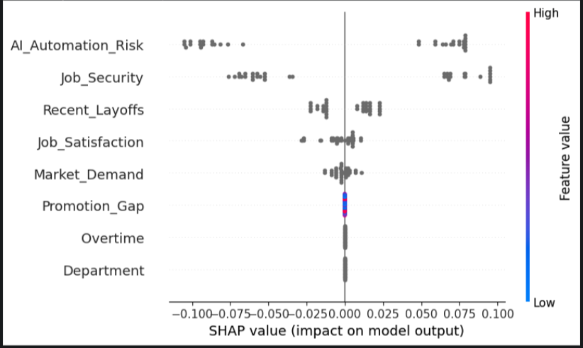
Based on the SHAP Summary Plot, there is a clear hierarchy of importance that dictates employee attrition in this dataset. The features are ranked by the magnitude of their impact (x-axis spread):
- AI_Automation_Risk: This is by far the most influential feature. The extremely wide spread of SHAP values indicates that an employee's perception of AI risk is the single biggest predictor of whether they stay or leave.
- Job_Security: The second most critical factor. The model heavily penalizes low job security, pushing those predictions toward "Leave."
- Recent_Layoffs: The third major driver. The presence of layoffs in a department acts as a strong signal for attrition.
- Negligible Features: Surprisingly, traditional retention metrics like Overtime, Promotion_Gap, and Department are low. This means they had low impact on the model's decision-making process.

B. What the model has learned

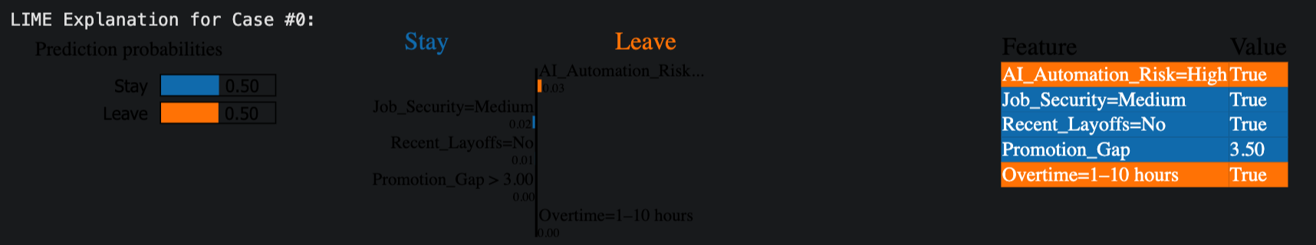

The model has moved beyond simple correlations and learned a specific behavioral narrative about this workforce:
- Fear > Burnout: The model has learned that "Existential Threats" (Will my job exist next year?) are far more powerful motivators than "Daily Frictions" (Am I working too much overtime?).
- The "Safety First" Hierarchy: By ignoring Overtime and Promotion_Gap in favor of AI_Automation_Risk and Job_Security, the model suggests that employees are operating at the "Safety" level of Maslow’s Hierarchy. They are not leaving because they want a better promotions; they are leaving because they don't feel safe.
- The LIME Evidence: The LIME analysis supports this. For Case #0 (a 50/50 split), the model shows a massive "Leave" push due to AI_Automation_Risk=High, which is barely counteracted by the fact that they haven't been fired yet (Recent_Layoffs=No). The anxiety of AI is nearly outweighing their current stability.

C. Does the model’s behavior align with domain knowledge?
The model's behavior is partially aligned with traditional domain knowledge but reflects a thoroughly modern reality:
- Where it Aligns (Psychological Safety): HR research consistently proves that "Job Insecurity" is a primary stressor. It makes sense that if people fear layoffs or automation, they will proactively look for new jobs. The model correctly identifies that you cannot retain a terrified employee with a small bonus or a title change.
- Where it Deviates : Traditional HR wisdom often cites "Burnout" (Overtime) and "Stagnation" (Promotion Gap) as top reasons for quitting. The fact that this model reduce them is significant. It suggests that in the current tech climate (marked by AI disruption and market volatility), these traditional concerns have become secondary. An employee might tolerate overtime if they feel their job is safe, but they will not tolerate instability even if their hours are good.
Conclusion: The model is valid and highly perceptive. It successfully identified that the organization is facing a stability crisis, not a workload crisis.

Section 05
While the CatBoost model achieved high performance metrics (Accuracy: 83%, ROC-AUC: 0.93), a critical evaluation reveals significant limitations and ethical risks that must be addressed before deployment.

5.1 Limitations of the Model
The primary limitation of this model is statistical fragility due to sample size.
- The "Early Stopping" Anomaly: As noted in the training logs, the model stopped learning after only 1 iteration. This occurred because the validation set contained only roughly 15 employees. With such a small sample, the model found a simple rule (likely related to AI Risk) that worked perfectly for those 15 people and stopped immediately.
- Lack of Complexity: Consequently, the model functions more like a simple "Decision Stump" rather than a complex Gradient Boosted Decision Tree. It has not learned nuanced interactions (e.g., how Overtime affects Satisfaction), limiting its ability to generalize to new, unseen employees who don't fit the dominant pattern

5.2 Data Quality Issues
The reliability of the results is directly tied to the quality of the input data collected via Microsoft Forms:
- Self Reporting Bias: Attrition intent is a sensitive topic. Even with guaranteed anonymity, respondents may exhibit "Social Desirability Bias," where they answer in a way they think is more professional, leading to an under reporting of true flight risks.
- Sample Size: With a dataset size of around 180 rows, the model is prone to "Small Data" issues where one or two outlier responses can disproportionately influence the global feature importance.

5.3 Risks of Bias or Unfairness
A significant risk in this project is Selection Bias.
- Representativeness: Because the Microsoft Form was primarily distributed through tech heavy networks (e.g., LinkedIn or IT Slack channels), the model may inadvertently learn that "AI Anxiety" is a universal driver, whereas it may not be as relevant for employees in non tech departments.
- Departmental Bias: If the AI_Automation_Risk is naturally higher in specific technical departments (e.g., Engineering or IT), the model may disproportionately flag these groups as "flight risks." This could lead to these departments receiving excessive scrutiny or, conversely, being passed over for long-term projects due to perceived instability.

5.4 Potential Real-World Impact and Ethical Considerations
The deployment of an "Employee Flight Risk" tool has massive ethical implications:
- The Surveillance State: If employees know an AI is monitoring their "Risk" score, it can create a "Big Brother" atmosphere. This may reduce workplace trust and actually increase the very attrition the model is trying to prevent.
- Informed Consent: Ethically, if this model were used by a real company, employees must be informed how their data is being used. Using survey data for machine learning without clear transparency on how the results affect career progression is a major ethical breach.
- Positive Intervention (The "Upskilling" Impact): On a positive note, the ethical use of this model would involve using the SHAP/LIME explanations to help people. If a model flags an employee because of "AI Automation Risk," a company can ethically respond by offering reskilling programs rather than marginalizing the employee.

Final Submission Checklist
According to your document, ensure you have these files ready:
- Written Report (PDF): Including all the sections we just drafted.
- Source Code: Your Google Colab/Python script (including the Preprocessing, CatBoost, SHAP, and LIME code).
- Dataset: The Excel/CSV file exported from your Microsoft Form.
- Bonus (10 marks): A 3-5 minute demo video if you choose to build a front-end system.

